**Topic - Recursion**

**Difficulty Medium: Lowest Common Manager:**

You're given three inputs, all of which are instances of an OrgChart class that have a directReports property pointing to their direct reports. The first input is the top manager in an organizational chart (i.e., the only instance that isn't anybody else's direct report), and the other two inputs are reports in the organizational chart. The two reports are guaranteed to be distinct. -

Write a function that returns the lowest common manager to the two reports.

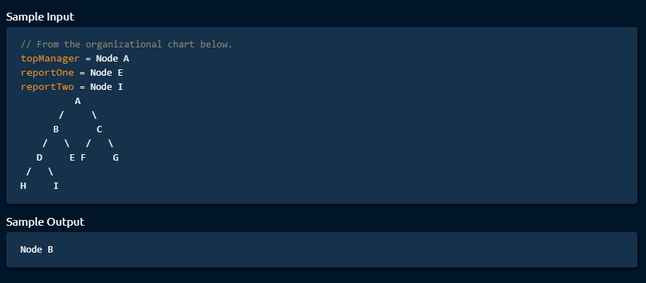

# Difficulty Medium: Interweaving Strings

Write a function that takes in three strings and returns a Boolean representing whether the third string can be formed by interweaving the first two strings.

To interweave strings means to merge them by alternating their letters without any specific pattern. For instance, the strings "abc" and "123" can be interwoven as "alb2c3", as "abc123", and as "ab1c23" (this list is nonexhaustive). Letters within a string must maintain their relative ordering in the interwoven string.

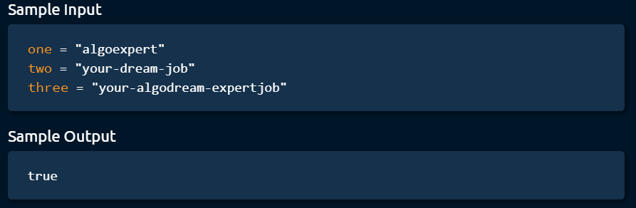

# Difficulty Medium: Solve Sudoku

You're given a two-dimensional array that represents a 9x9 partially filled Sudoku board. Write a function that returns the solved Sudoku board. Sudoku is a famous number-placement puzzle in which you need to fill a 9x9 grid with integers in the range of 1-9. Each 9x9 Sudoku board is split into 9 3x3 subgrids, as seen in the illustration below, and starts out partially filled.

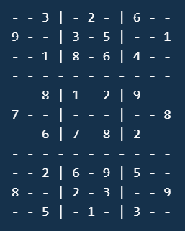

The objective is to fill the grid such that each row, column, and 3x3 subgrid contains the numbers 1-9 exactly once. In other words, no row may contain the same digit more than once, no column may contain the same digit more than once, and none of the 9 3x3 subgrids may contain the same digit more than once. Your input for this problem will always be a partially filled 9x9 two- dimensional array that represents a solvable Sudoku puzzle. Every element in

Thank you for using [www.freepdfconvert.com](http://www.freepdfconvert.com/) service!

Only two pages are converted. Please Sign Up to convert all pages. <https://www.freepdfconvert.com/membership>